COMPARATIVE STUDY OF ACTIVATION FUNCTIONS AND OPTIMIZATION ALGORITHMS IN DEEP LEARNING

Visualization of activation functions:
Comparison of activation function:
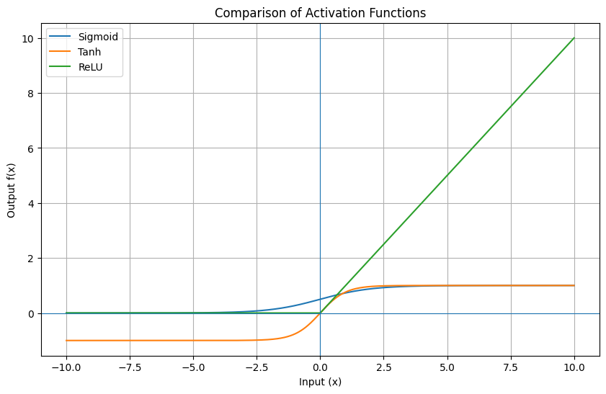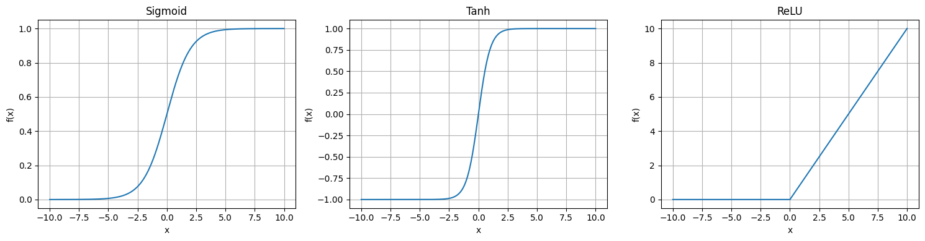

Performance comparison of activation functions:
Sample image:
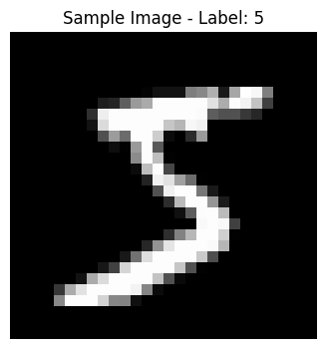
Training and Validation accuracy comparison:
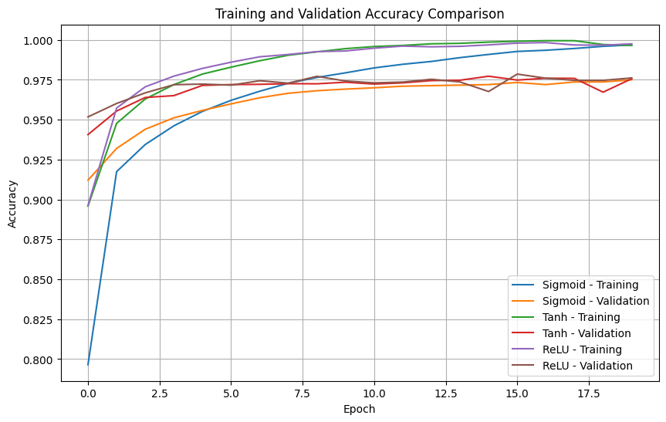
Training and Validation loss comparison:
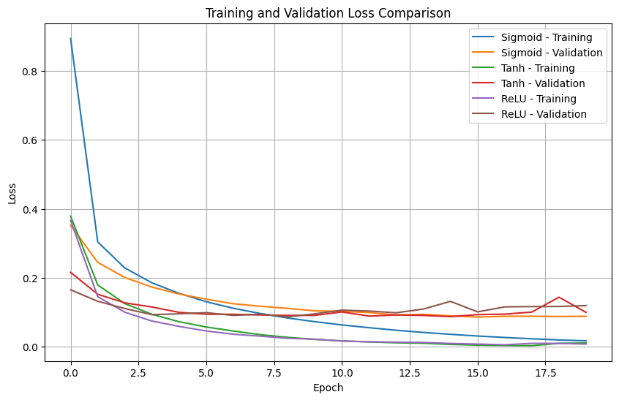

Validation accuracy comparison:
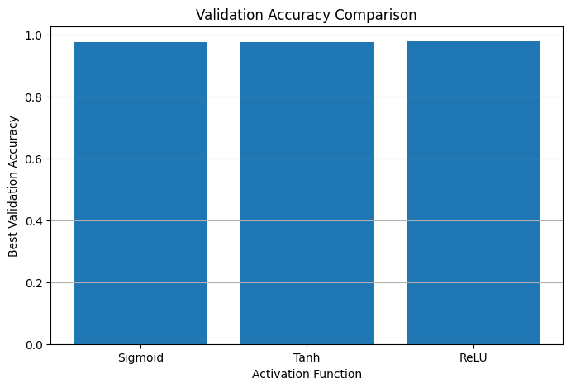

Comparison of Optimization algorithms:
Training Loss vs Epoch:
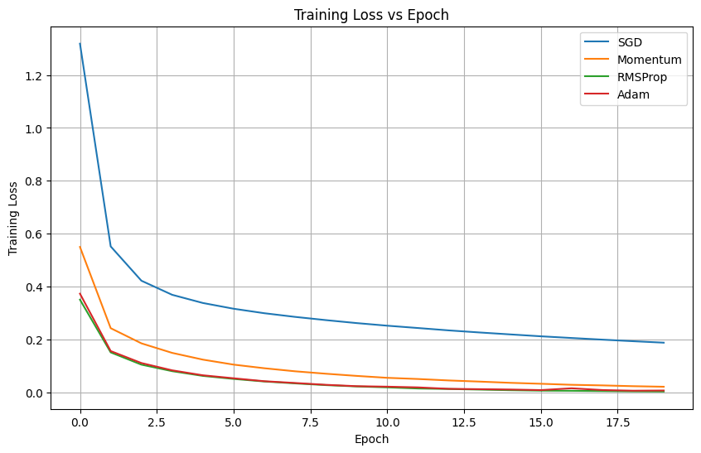
Validation loss vs Epoch:

Training Accuracy vs Epoch:
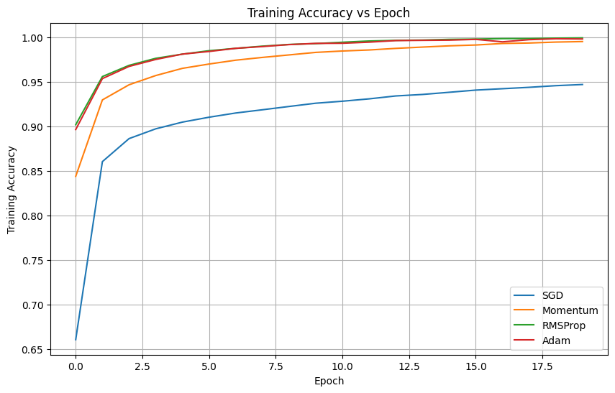

Validation accuracy vs Epoch:
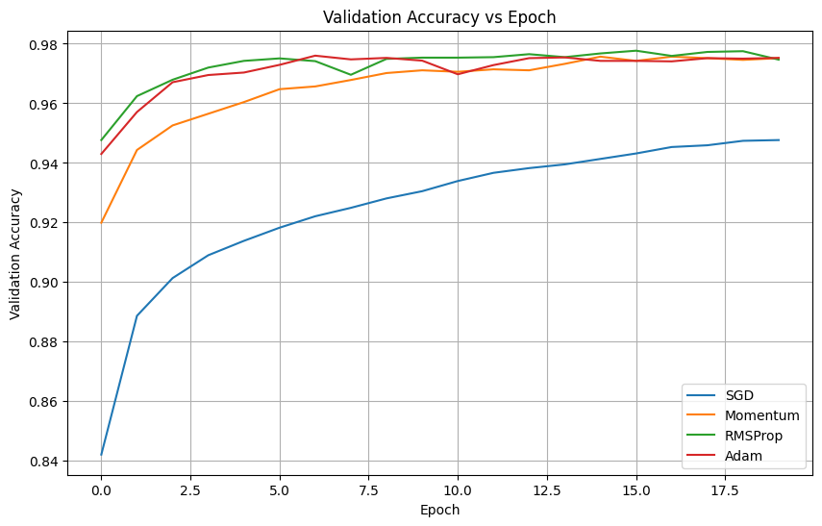
Final validation accuracy comparison:
